FoGG Volunteer Gardening Group end of year meeting, 30th September, 2019

1. SESSIONS STAY THE SAME -TIMES+ NUMBER in MONTH
2. WE RECORD WHATS GROWING IN FLAGPOLE BED
3 GRASS CUTTING, EDGING and LEAF BLOWING
4. HIGH VIS VOLUNTEER GARDENER JACKETS TO BE PURCHASED
5. FUNDING APPLICATIONS FOR Future project

1. We discussed whether people wanted to extend the sessions but it was felt until numbers of volunteers increases substantially we stick to the sessions of 2nd and 4th Saturday morning and 2nd Wednesday afternoon of the month working in the areas we have agreed to manage and people can go into the gardens at any time and do a bit of extra if they wish.
2. We agreed that it would be a good idea to record what was growing in the Flag pole bed throughout the seasons.
Narissia has said she will download a google map of the park and divide the flagpole bed into three areas. Gardeners can add information to this as plants appear throughout seasons. In this way we will be able to see where we need to replant or move things.
Barbara and Richard have agreed to monitor and record a third of the bed up to the curve to the left of the bench.
Eleanor and Liz will record what they find from the curve to the flagpole.
Adi and Col will record from the flagpole to the Poetry bench
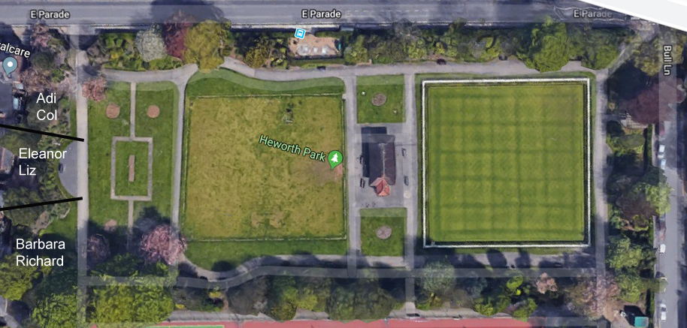
3. Chris Hart has agreed to do the cutting of the grass and is liaising with Les Gee re using the lawnmower in the Mosaic garden shed. We agreed that it may need one more cut this year weather permitting.
Jonathan and Karen have undertaken the edging and Karen is waiting to hear from the council about doing a leaf blowing induction so that we can use the leaf blower which June has kindly stored in their garage.
It was agreed that when a date is set for a leaf collecting session an email is sent out so that a group can help collect the leaves It was agreed that a having a leaf compost bin would be a good idea and I will see if we can get permission to erect one in the back of one of the borders
4. Karen, Adi, Barbara and Coleen recently visited the Rowntree Park volunteer gardeners. This was an interesting visit and shows how gardening groups are similar in lots of ways but also have different problems. As a result of this visit we discussed whether we should wear high vis jackets with words VOLUNTEER Gardener on the back in prominent lettering for a few people to wear when we have a session. This is to let the public know (and hopefully encourage people to join us) but also to redirect any criticism park visitors have to the council and not to us. Karen to investigate
5. We were also made aware of the number of organizations which can be applied for funds for projects. I have narrowed down the list to relevant organisations and will discuss with FoGG treasurer at next FoGG meeting and ask if he can apply on our behalf. This is for a possibly bigger project to be discussed at FoGG meeting ie working on the bed near the tennis court .Liz Maynard has agreed to contact a friend who works at the Castle Howard Arboretum for advice on the trees and shrubs in this area.
We were disappointed that Mathew (Askham Bryan horticultural student) had had to pull out of his work experience opportunity at Glen gardens as we would have liked him to work on the Bull Lane bed which was renovated last year. Liz has agreed to contact her gardener again to come and re do areas .We agreed that the area on the left as you come in from the Co-op entrance needs attention.

Our discussion was followed by a lovely hour of chat, drinks and nibbles.

Can I thank all who came and all of you who couldn’t come but continue to contribute to Glen Gardens in lots of different ways

We will keep going until end of October weather permitting but will be back again in the gardens in March 2020

